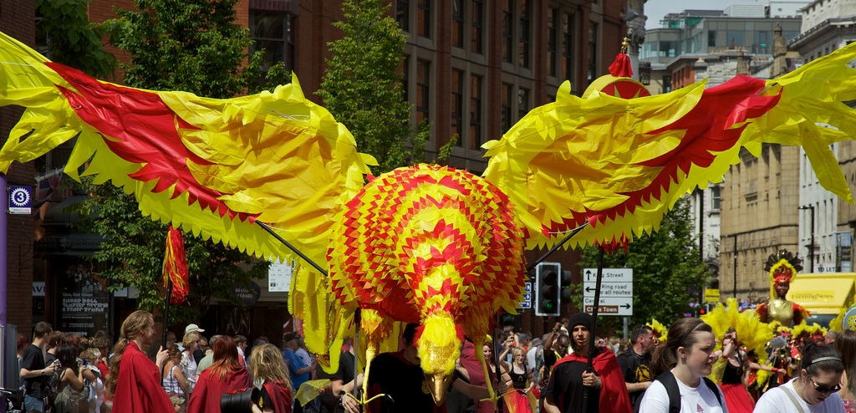
What is MSS?
Manchester School of Samba (MSS) formed in March 1995 to foster the appreciation of Brazilian Carnival culture through rhythm, melody, dance and simple costumes. MSS have provided an often life enhancing introduction to percussion and dance for hundreds of people as well as an opportunity for some to build on their knowledge and strengths and be inspired to subsequently form their own bands. We still focus on carnival art forms, and are open to all people. We currently have 60 fully fledged members including dancers and drummers. For special occasions we also like to include a brass section and puppeteers.

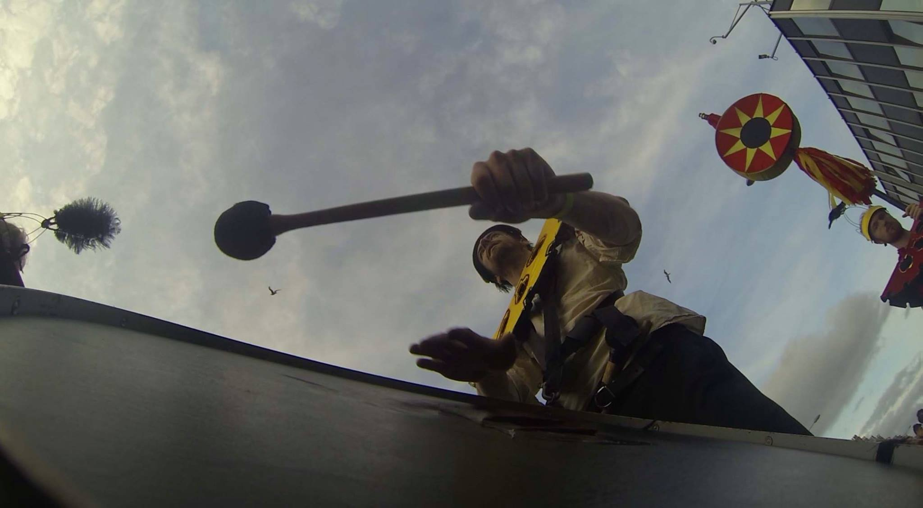

Can I Play?
We meet at Sacred trinity Church, Chapel Street, Salford, M3 5DW, every Wednesday for a very sociable rehearsal. We will spend time bringing newcomers up to speed in both existing percussion pieces and their associated dance routines and whatever new material we devise. We provide drums & percussion.
play...

© Peter Richardson
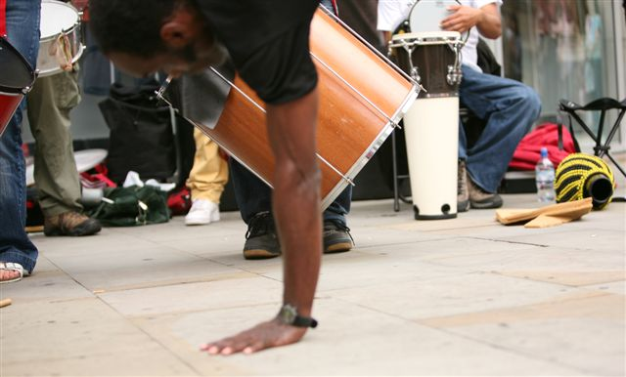
Play for Me!
With over a decade's experience of providing crowd stopping shows, inspirational workshops and courses for schools and colleges, and motivational team building for a range of corporate clients if you are organising a function or event we are sure MSS can help to provide that extra magic.

hire MSS...

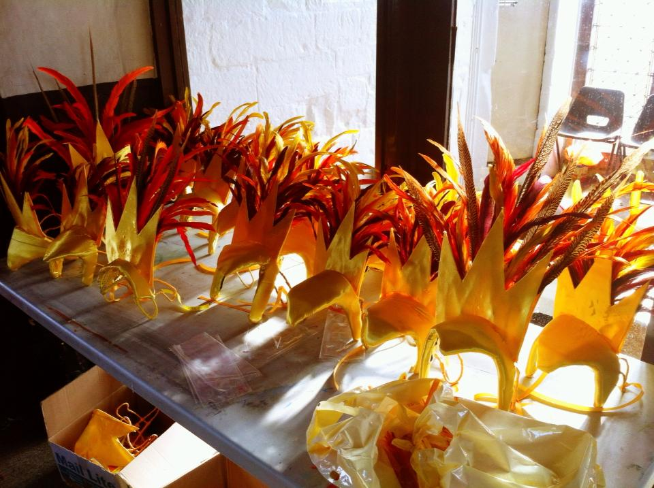

What can taking part do for me?

- Generate a mental aptitude for inclusion
- Develop self expression and listening and movement skills
- Stimulate the creative thought process
- Promote co-operation
- Reduce stress levels
- Demonstrate the individual effect on the larger whole
- Experience teamwork
- Illustrate the benefits of diversity
- Enable you to have lots of fun

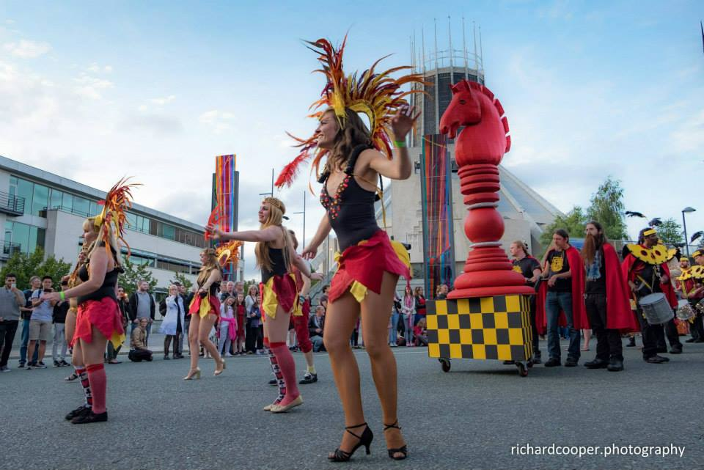

Contact MSS
For information about us please contact:


Tony Watt
Director
Manchester School of Samba

18 Lansbury House
76 Whalley Road
Whalley Range
Manchester
England
M16 8AH

Telephone: +44 (0)161 232 1984
Fax: Use phone number to notify us first
Mobile: +44 (0)7770 916330

Email: agogo2@gmail.com

Picture credits: Peter Richardson, Richard Cooper, Peter Birkinshaw, Laren Moore, Sam Pratt.

